**Welcome to the BSOG UG Quiz 2022! Date: 29.3.2022**

**Venue: Bhagwan Mahaveer Jain Hospital**

**Time: 12.00-1.00pm Marks- 70**

**Name:**

**Institution:**

**Doing Internship: yes/ no**

**Mobile number:**

**Each of these questions has a single correct answer. If you scratch or overwrite, marks will be deducted. Each right answer fetches 1 mark. The Quiz Master’s decision is final.**

**15 marks**

**1. Mc Robert’s manoeuvre for shoulder dystocia is a. Hyperflexion and abduction of hip b. Hyperextension and abduction of the hip c. Hyperextension and external rotation of the hip d. Hyperflexion**

**2. Postoperative secondary haemorrhage is due to a. Loosening of ligatures b. Failure to secure bleeder c. Coagulation failure d. Infection**

**3. Nonoxynol 9 is a a. Ingredient of OC pill b. Ingredient of injectable contraceptive c. Embryotoxic agent d. Spermicidal agent**

**4. Strawberry vagina is seen in a. Candida albicans b. H.Vaginalis c. Syphilis d. Trichomonas vaginalis**

**5. Amsel’s criteria is used to diagnose**

**a. Bacterial vaginosis**

**b. Vaginal candidiasis**

**c. Trichomonas vaginalis**

**d. Gonococcal infection**

**6. Rotterdam’s criteria for PCOS includes**

**a. Oligo/anovulation, Hyperandrogenism, polycystic ovaries on USG**

**b. BMI>25, Hyperandrogenism, anovulation**

**c. Acanthosis nigricans, anovulation, polycystic ovaries on USG**

**7. HAIR-AN syndrome is characterized by all except**

**a. Hyperandrogenism**

**b. Association with PCO**

**c. Diabetes mellitus Type 1**

**d. Black velvety patch over the nape of the neck**

**8. High FSH and LH levels in an 18-year-old short statured girl is suggestive of**

**a. Pituitary adenoma**

**b. Ovarian failure**

**c. Absent uterus (MRKH syndrome)**

**d. CAH**

**9. Treatment of choice for Bartholin’s cyst/abscess**

**a. Excision**

**b. Marsupialization**

**c. I and D**

**d. Any of the above**

**10. RMI is used for knowing the malignant potential of a. Vaginal ca b. Ovarian tumour c. Ca cervix d. Uterine sarcoma**

**11. Serum Prolactin is increased in all the following except a. Hyperthyroidism b. Pregnancy c. Hypothyroidism d. Phenothiazine therapy**

**12. A baby of a diabetic mother can have all except a. Hypoglycemia b. Hypercalcemia c. Hyperbilirubinemia d. Polycythaemia**

**13. Enzyme that converts testosterone to Estradiol is a. 17 alpha hydroxylase b. Aromatase c. 5 alpha reductase d. 17-20 lyase**

**14. All of the following may be associated with oligohydramnios except a. Pre-eclampsia b. Maternal type 1 diabetes with vasculopathy c. Posterior urethral valve in the baby d. Duodenal atresia in the baby**

**15. MTP Act allows pregnancy termination till a. 12 weeks b. 20 weeks c. 22 weeks d. 24 weeks**

**2. State True or False 10 marks 1mark each**

**1. Sublingual Nifedipine is the first line of treatment for controlling severe hypertension in Pre-eclampsia. False. Not Recommended**

**2. Atenolol can cause IUGR in the baby. True**

**3. Asymptomatic bacteruria need not be treated in pregnancy. False. If detected, should be treated**

**4. Mifepristone is a progesterone agonist. False. Progesterone Antagonist**

**5. Misoprostol has to be maintained at 4o C temperature for its optimum action. False. Room Temperature**

**6. Original squamocolumnar junction is closer to the external os than the new squamocolumnar junction. False- NSCJ is closer**

**7. CO2 can be used as a distension media for hysteroscopy as well as for creating pneumoperitoneum in laparoscopy. True**

**8. Early decelerations in a CTG are the commonest type of decelerations found during labour. False. Variable**

**9. To reduce bleeding during myomectomy, vasopressin is the best agent. True**

**10. High risk HPV types are 6 and 11. False. 16 and 18**

**3. Fill in the Blanks 1 mark each 10 marks**

**1. LNG IUS is a …third………generation IUCD**

**2. The main blood supply to the perineum is from the Internal Pudendal artery**

**3. Spalding’s sign is found In IUFD/IUD**

**4. Karman’s cannula is used for D & E/MVA/MR procedure**

**5. Anaemia is diagnosed in the 2nd trimester of pregnancy with a Hb level less than 10.5gm%**

**6. Radical vaginal hysterectomy with PLND is - SCHAUTA-MITRA’S OPERATION**

**7. When you combine tubectomy along with cesarean delivery it is known as**

**Concurrent tubectomy**

**8. Anterior Asynclitism is also called as Naegles Asynclitism**

**9. If the curve of Carus is C shaped, Obstetric axis is J shaped.**

**10. The pressure built during ventouse delivery is about 600-700mm of Hg**

**4. Match the following 1 mark each 5 marks**

**a. De lancey i. USG in obstetrics**

**b. Victor Bonney ii. Cervical cancer**

**c. Shirodkar iii. Genital prolapse**

**d. Ian Donald iv. Cervical insufficiency**

**e. Meig v. Leiomyoma uteri**

**vi. Endometriosis**

**Ans: a-iii b—v c-iv d-i e-ii**

**5. Cross word puzzle 12 marks**

**Horizontal (numbers in black)**

1. **Vaginal Speculum selfretaining with two cusps (5)**
2. **Mutation of this gene can cause Ovarian cancer (4)**
3. **The groove sign to differentiate uterine fibroid from ovarian tumour, not just for a queen (9)**
4. **Intravenous magnesium sulphate regime in eclampsia, last resort? (6)**
5. **Breast and pubic hair development are staged by….. Staging, even for blonde hair ((6)**
6. **Ovarian reserve marker though against mullerian (3)**

**Vertical (Numbers in red)**

1. **Ultra sound system used for differentiating benign from malignant ovarian tumours (4)**
2. **The counting system used for fetal kick count, capital of wales (7)**
3. **X Ray appearance of fetus in breech presentation with extended neck, astronaut in the making? (10)**
4. **Clomiphene, gonadotropins can cause this complication Hshhhh (4)**
5. **One of the components of the double marker test (5)**
6. **One of the complications of an ovarian cyst (7)**

|  |  |  |  |  |  |  |  |  |
| --- | --- | --- | --- | --- | --- | --- | --- | --- |
|  | **1**C **2** | U | S **3** | C | O  **4** |  |  | T **6** |
|  | A |  | T |  | H |  |  | O |
| **2**B | R | C | A |  | S |  |  | R |
|  | D |  | R |  | S | P **5** |  | S |
|  |
| **3**H | I | N | G | O | R | A | N | I |
|  | F |  | A |  |  | P |  | O |
| I  **1** |  |  | **4**Z | U | S | P | A | N |
| O |  |  | I |  |  | A |  |  |
| **5**T | A | N | N | E | R |  |  |  |
| A |  |  | G |  |  | **6**A | M | H |

**6. Write two procedures/ instruments associated with any 5 of the following names – 10 marks 2 marks each**

1. **Bonney**

**Myomectomy clamp**

**Hood operation**

**Myoma screw**

**Bonney’s test**

1. **Shirodkar**

**Hook**

**Sling operation**

**Encerclage**

**Modification of Fothergill’s**

1. **Munro Kerr**

**Kerr’s incision**

**Munroker’s method of CPD assessment**

1. **Purandare**

**Purandare’s sling**

**CPD assessment method**

1. **Pinard**

**Fetoscope**

**Maneuver in vaginal breech**

1. **Rubin**

**Cannula for HSG**

**Test for tubal patency (Air insufflations)**

**Maneuver for shoulder dystocia**

1. **Identify 1 mark each 4 marks**
2. 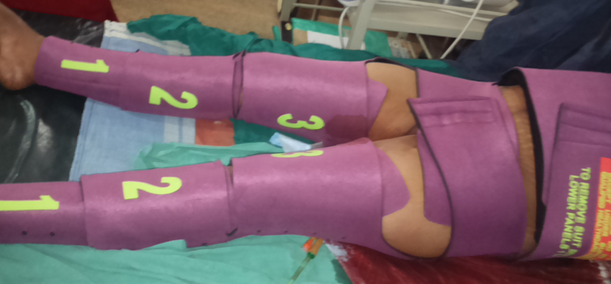

**Anti shock garment NASG**

1. **The maneuver shown in the picture for the delivery of the aftercoming head in an assisted breech delivery is**

**Mauriceau Smellie Veit method**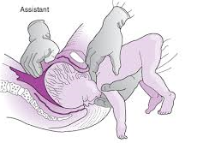

1. **Name the procedure**

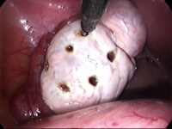

**Laparoscopic Ovarian Drilling**

1. **Identify**

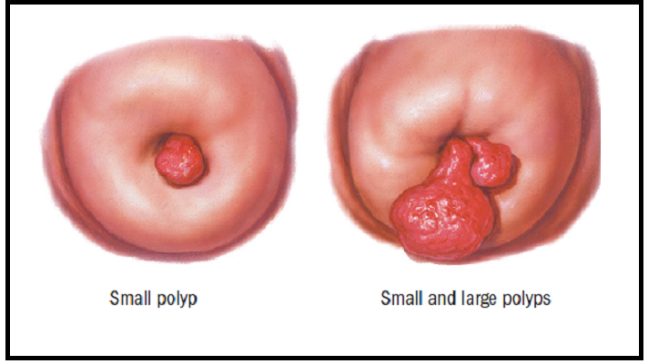

**Cervical Polyp**

1. **Expand the following abbreviations--- 1 mark each 4 marks**

**VIN (VULVAL INTRAEPITHELIAL NEOPLASIA)**

**CTG (CARDIOTOCOGRAPHY)**

**ICSI (INTRACYTOPLASMIC SPERM INJECTION)**

**PC-PNDT (PRE CONCEPTION AND PRENATAL DIAGNOSTIC TESTING)**

-------------------------------------------------------------------------------------------------